Altoconnect theme
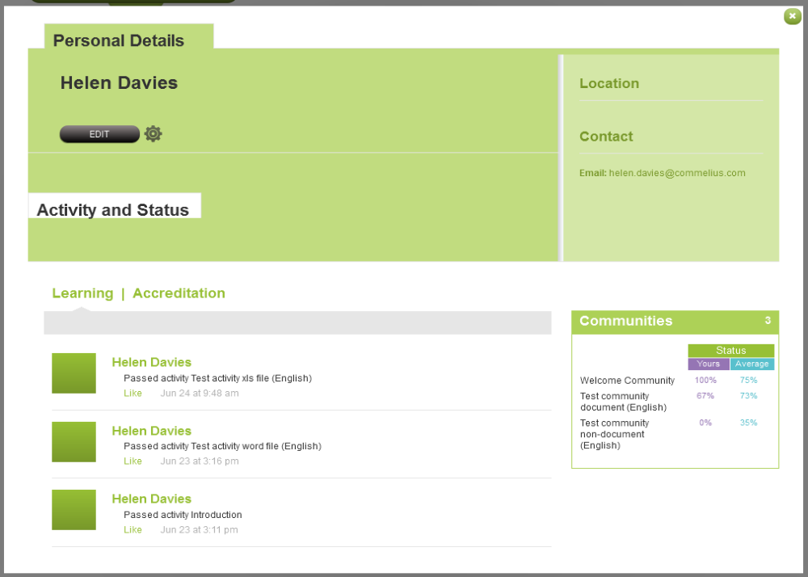

Unilever theme
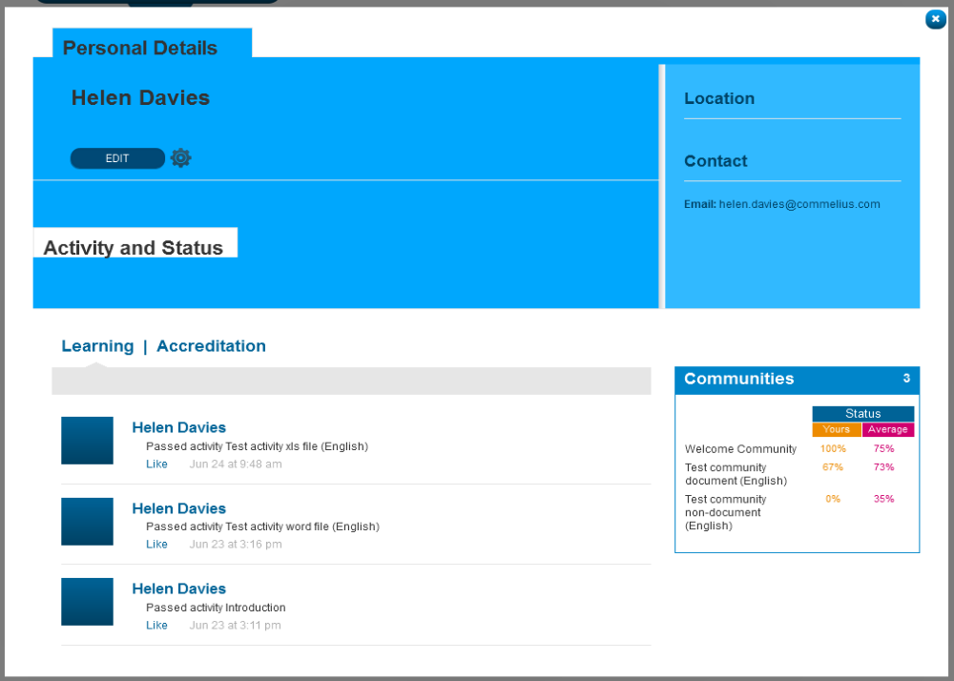

NATS theme
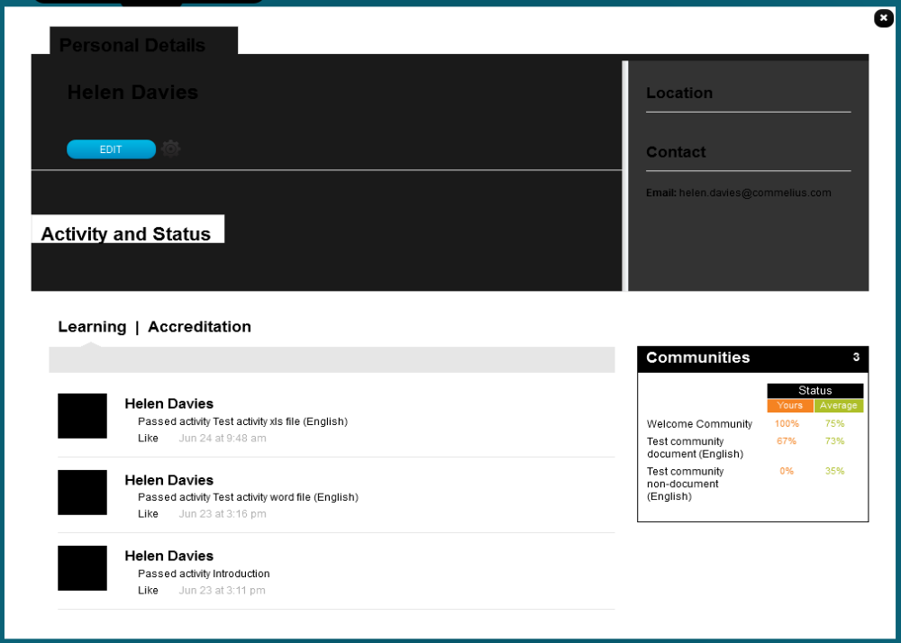

Nokia theme
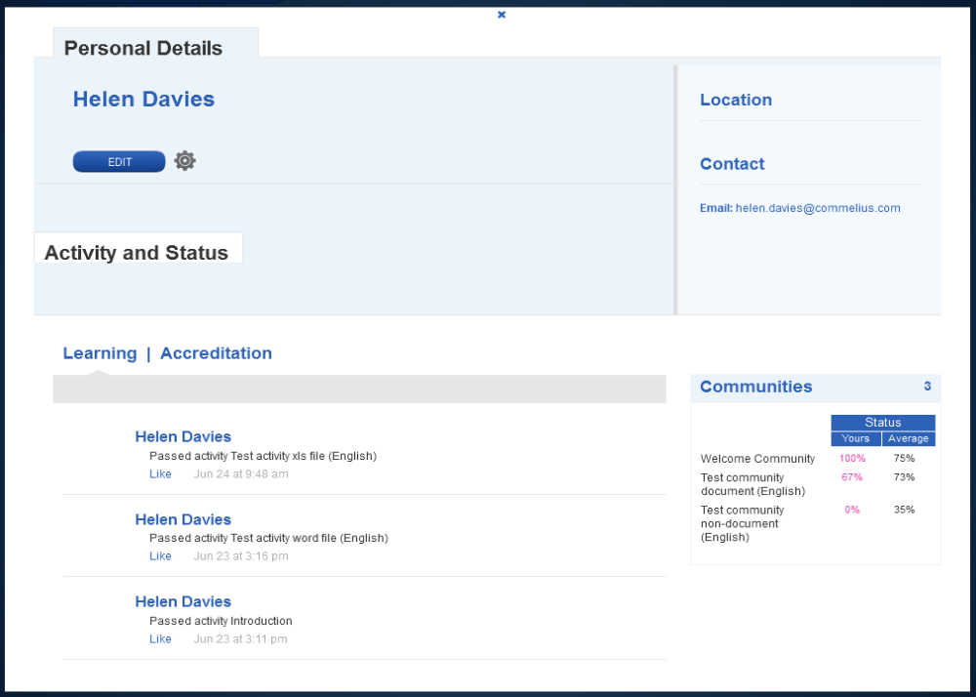
Primary tint 2 or white with Alpha
White
Primary tint 1

Problems with the application of the theme:
- Personal details: Primary tint 1 is too dark a tint on all but Nokia – it needs to give good contrast with the default text colour applied. Default text colour will always be dark because it is sitting on a white background at least within the centre circle, so we can assume that this block of colour needs to be a pale tint of Primary colour. I suggest 20% tint of the Primary colour.
- Location & Contact: I think this was designed with a gradient on the left to appear like pages in an address book. The gradient seems to be an image, so it appears as a white block – not attractive. It needs transparency applied, and maybe more thought applied to it so it works against all colours.
- Activity and status: This heading has a white background on all instances, not sure if this is intentional – it looks weird. What appears beneath it?

